Business Understanding

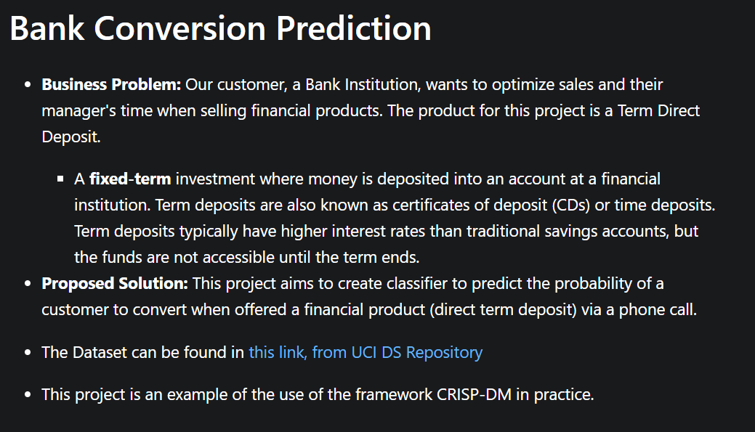

Dataset
Moro, S., Rita, P., & Cortez, P. (2014). Bank Marketing [Dataset]. UCI Machine Learning Repository. https://doi.org/10.24432/C5K306.

The Dataset can be found from UCI DS: Repository](https://archive.ics.uci.edu/dataset/222/bank+marketing)

1. Data Understanding


1.1 Keys and duplicates:
The UCI Bank Marketing dataset does not have a unique identifier column since the goal is not to identify the customer in real world, but to predict with the features provided during the campaign to predict if the customer would subscribe to the offer. For our scenario, a duplicated record does not necessarily mean the same customer appears twice. Two different customers can have identical values across all recorded features. Also, repeated campaign contacts may be legitimate records, so investigation of the duplicates is necessary before any deletion.

Key highlights from the data description:

- Age of the customers is 40 years old on average. Distribution skewed to the right with a maximum of 98.
- More than 25.3% of the customers are admin.
- Most of the customers are married, with university degree, and 52.4% have house loan.
- Only ~0.01% had payment default. default is no for 79.1% of customers and unknown for about 21%, with almost no yes values
- Conversion Rate ~ 11.27% (4,640 of 41,188), so the target is imbalanced at about 8 to 1.
- poutcome = nonexistent for 35,563 rows (86.3%): most clients were never contacted before.
- pdays = 999 is the placeholder for those clients, which is why the mean (962) and the quartiles (999) are meaningless.
- duration and campaign have means well above their medians and extreme maxima (4918 and 56), so both are strongly right-skewed.
- duration has a minimum of 0. Those calls have no talk time and are always no, which supports dropping it for a predictive model.
- month = may accounts for 33.4% of contacts, so the campaign activity is concentrated in a few months.

1.2 Distribution of target variable y
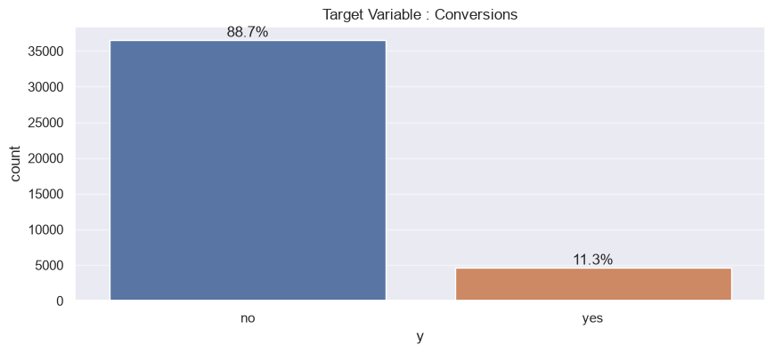
The target variable is very imbalanced since we have a very less conversion rate of 11.3%

1.3 Univariate Structure (numeric)
We have 10 numeric variables. The aim is to get a description of numeric variables alone to get a first hand view of data skewness, possible outliers. Below is a summary of the description:
 | count | mean | std | min | 25% | 50% | 75% | max
age | 41188.0 | 40.02 | 10.42 | 17.00 | 32.00 | 38.00 | 47.00 | 98.00
duration | 41188.0 | 258.29 | 259.28 | 0.00 | 102.00 | 180.00 | 319.00 | 4918.00
campaign | 41188.0 | 2.57 | 2.77 | 1.00 | 1.00 | 2.00 | 3.00 | 56.00
pdays | 41188.0 | 962.48 | 186.91 | 0.00 | 999.00 | 999.00 | 999.00 | 999.00
previous | 41188.0 | 0.17 | 0.49 | 0.00 | 0.00 | 0.00 | 0.00 | 7.00
emp.var.rate | 41188.0 | 0.08 | 1.57 | -3.40 | -1.80 | 1.10 | 1.40 | 1.40
cons.price.idx | 41188.0 | 93.58 | 0.58 | 92.20 | 93.08 | 93.75 | 93.99 | 94.77
cons.conf.idx | 41188.0 | -40.50 | 4.63 | -50.80 | -42.70 | -41.80 | -36.40 | -26.90
euribor3m | 41188.0 | 3.62 | 1.73 | 0.63 | 1.34 | 4.86 | 4.96 | 5.04
nr.employed | 41188.0 | 5167.04 | 72.25 | 4963.60 | 5099.10 | 5191.00 | 5228.10 | 5228.10

Based on above univariate numeric stucture, we will calculate the skewness for each followed by the univariate bar plots
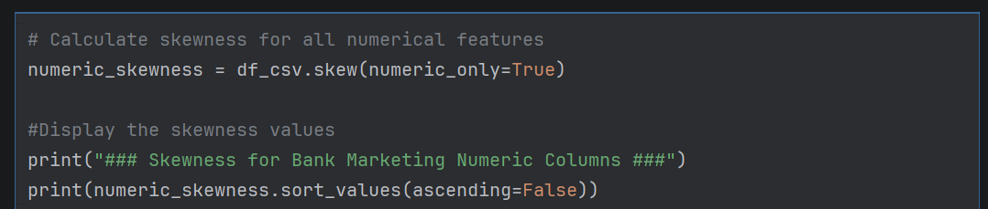
### Skewness for Bank Marketing Numeric Columns ###
campaign | 4.762507
previous | 3.832042
duration | 3.263141
age | 0.784697
cons.conf.idx | 0.30318
cons.price.idx | -0.230888
euribor3m | -0.709188
emp.var.rate | -0.724096
nr.employed | -1.044262
pdays | -4.92219

Strong right skew: Columns that fall in this group are campaign, previous, duration. Most values are small, with a long tail of large ones
Strong left skew: pdays has a strong left skew. Caused by the 999 placeholder, not a real distribution.
Moderate skew: age, euribor3m, emp.var.rate, nr.employed. Driven by period groups or clusters as these are economic indicators and they move together. They have less values as they are either quarterly or monthly indicators
Roughly symmetric: cons.conf.idx, cons.price.idx. No transformation needed.

1.4 Univariate Analysis of Categorical Columns Summary
Below is a univariate analysis of the categorical columns which can be divided into below categories (details in the notebook).
- the dominant categories (for example admin. in job, married in marital)
- rare categories if any, which may need grouping in Data Preparation
- unknown values, which are missing data in disguise (most visible in default, education, housing, loan, job and marital)
- imbalance within a column, such as nonexistent making up about 86% of poutcome

1.5 Bivariate Plots: Which features move with default

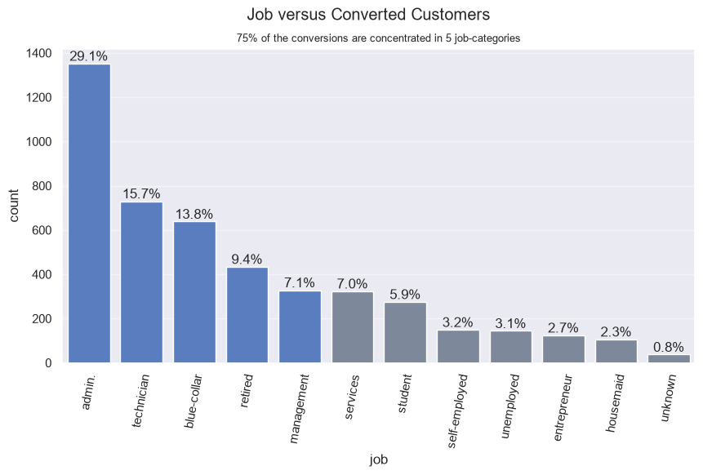

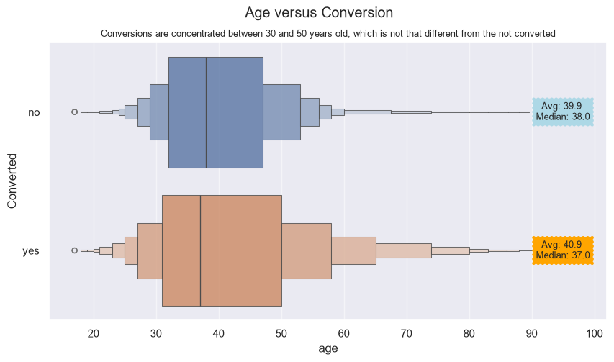

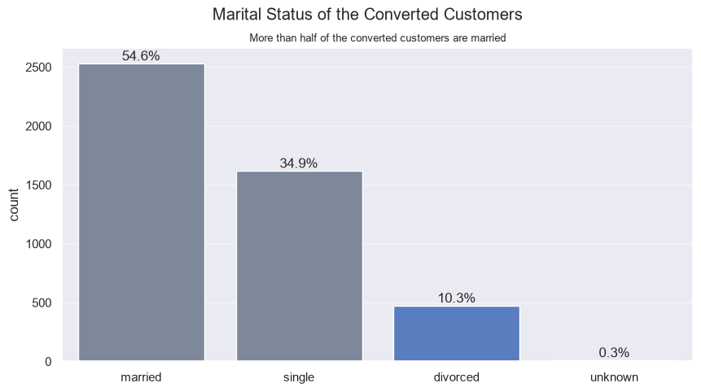

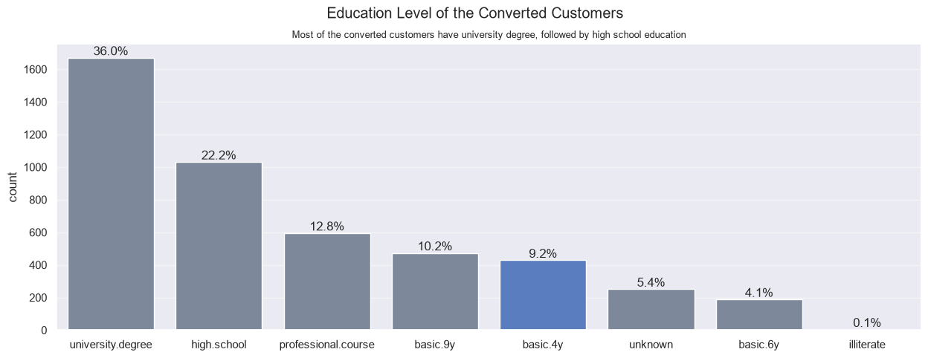

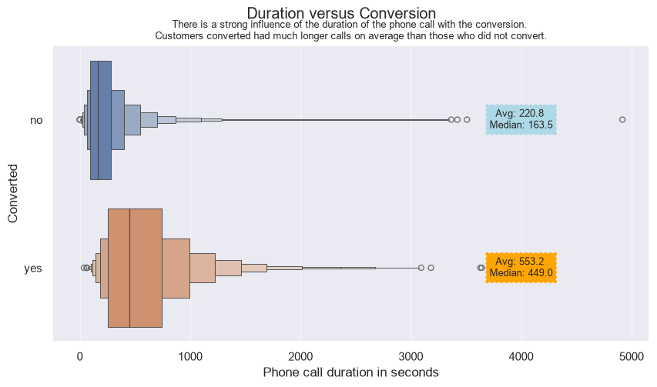

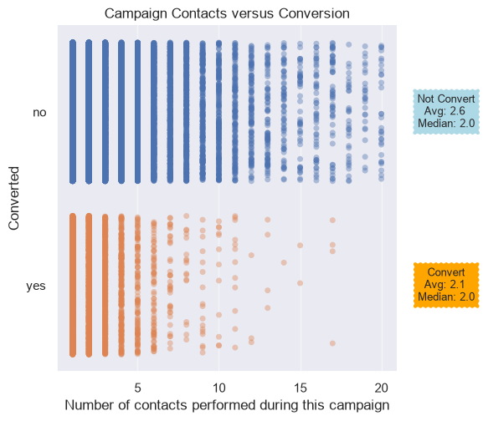

- Both groups pile up at 1 to 3 contacts. The dense columns on the left are the bulk of the data. Your annotations say both groups have a median of 2.
- Non-converters have a longer tail. The no points continue up to 20 (the edge of the plot), while the yes points thin out after about 6 contacts and become isolated dots beyond 10. The last visible conversion is around 17.
- The means differ slightly. About 2.6 contacts for non-converters vs. 2.1 for converters. The gap exists because of the tail, not because of the typical client, since the medians are identical. 0.5 contacts on average, with the same median. Campaign alone is a weak separator of yes and no

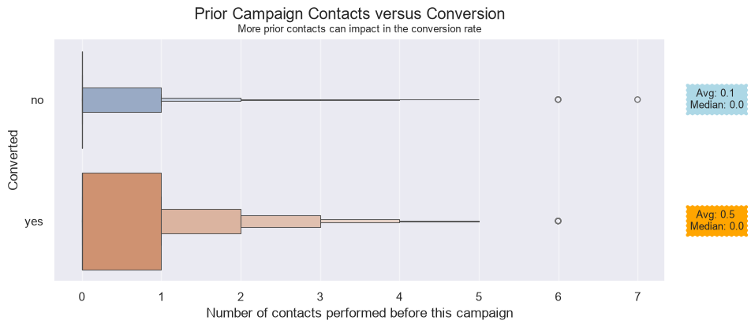

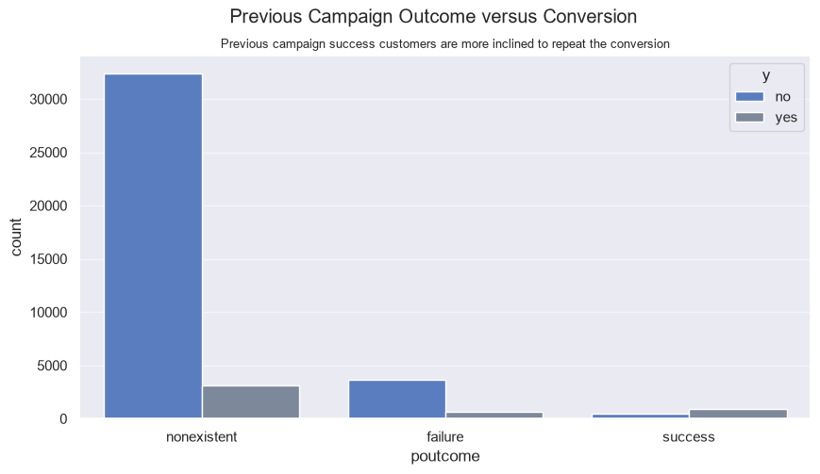
poutcome is a strong signal: clients who subscribed in a previous campaign are far more likely to subscribe again, while the large “no history” group converts at a low rate.
What the chart shows
- Non-existent dominates. It holds about 86% of all rows (35,563 in describe() output), so it also contributes most of the yes answers in absolute terms, even though its rate is low. This category implies that no previous campaigns were done
- success is the only category where yes outnumbers no. It is a small group, but its conversion rate is roughly seven times the nonexistent rate.

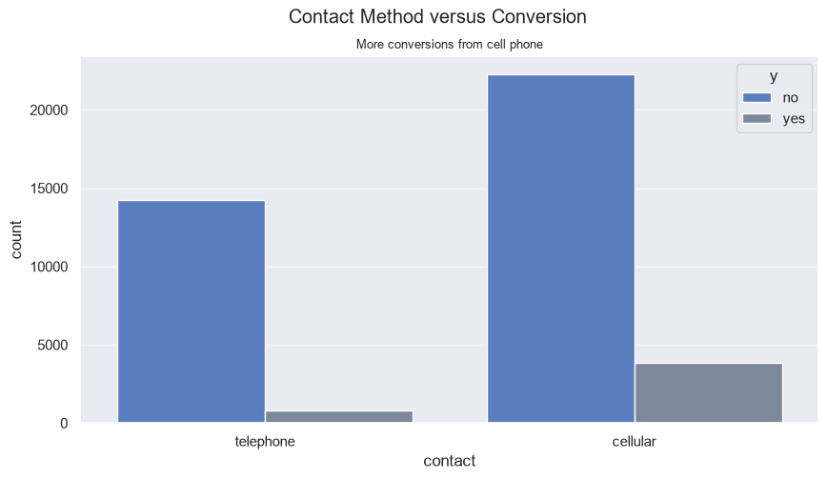

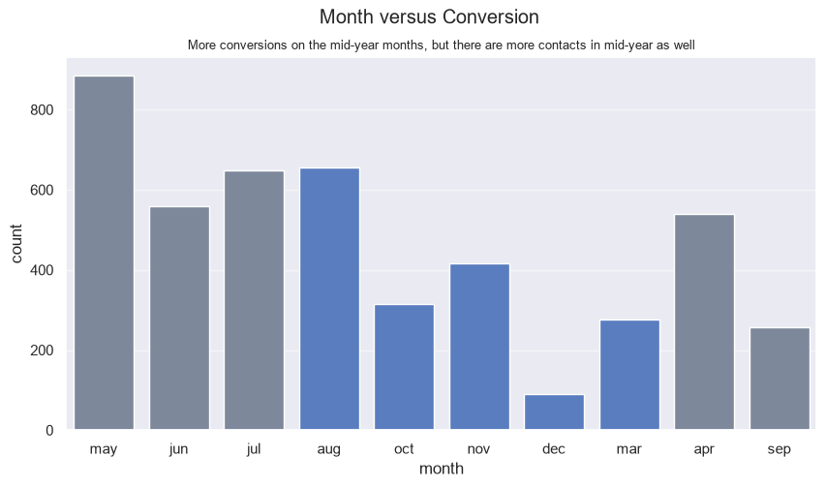

Day versus Conversions

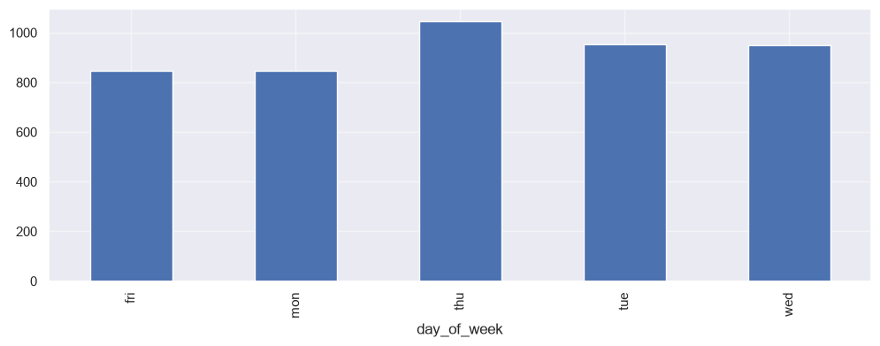

We see not much difference between the conversion rates. This will have not much impact on the final variable

pdays conversions:

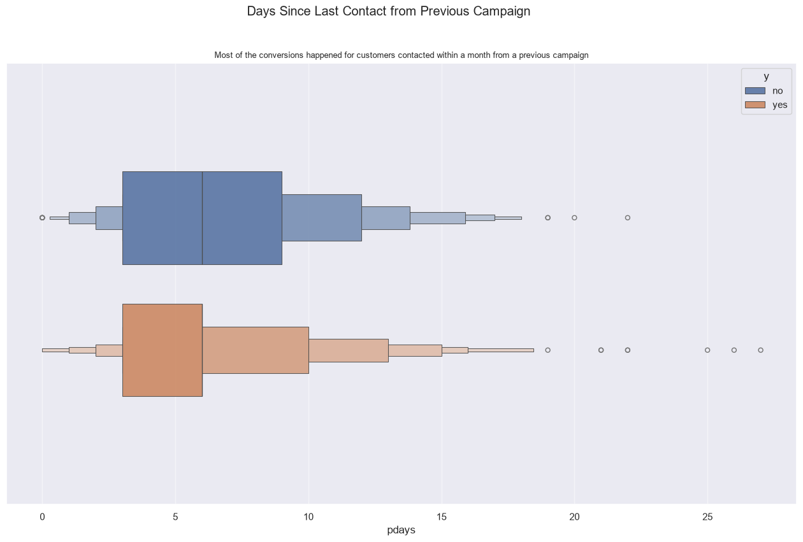
- Scale: the x-axis only runs from 0 to about 27 days, so every client here was recontacted within a month of the previous campaign.
- Non-converters (no): the widest box, roughly the middle half of the clients, spans about 3 to 9 days, with the median line at about 6. The tail continues to about 18 days, with outliers at 19, 20 and 22.
- Converters (yes): the widest box spans about 3 to 6 days, so it sits further left and is narrower. The tail reaches about 18 days, with outliers at 19, 21, 22, 25, 26 and 27.
- Overlap: both groups start at the same lower end (about 3 days), but the no group extends further into the 6 to 12 day range.

Housing vs Conversion

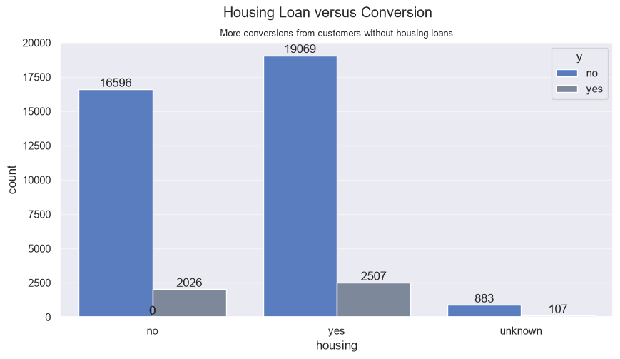
housing | Clients | Conversions | Rate
yes | 21,576 | 2,507 | 11.6%
no | 18,622 | 2,026 | 10.9%

housing shows a large difference in counts but almost none in conversion rate, so it is likely a weak predictor.

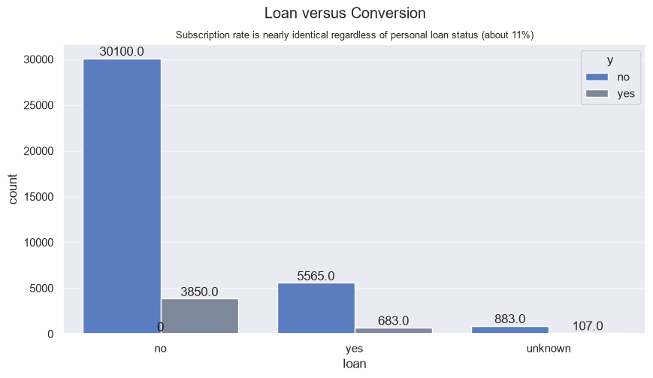
Customers with no personal loans have converted more compared to customers with personal loans. Since the data is simply following the distribution, lets examine if the conversion rates make an impact.

loan | no | yes | Total | Subscription rate
no | 30,100 | 3,850 | 33,950 | 11.30%
yes | 5,565 | 683 | 6,248 | 10.90%
unknown | 883 | 107 | 990 | 10.80%
All | 36,548 | 4,640 | 41,188 | 11.27%

Personal loan status shows little association with conversion: the subscription rate is 11.3% for clients without a personal loan, 10.9% for those with one, and 10.8% for unknown, all close to the overall rate of 11.27%. Clients without a loan account for most conversions only because they are the largest group (about 82% of clients). The unknown category (about 2.4% of rows) appears to overlap with unknown in housing. loan is expected to be a weak predictor and will be reviewed in feature selection.

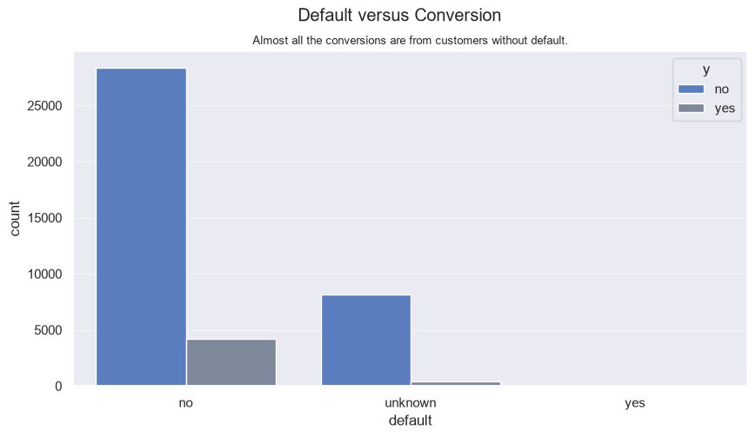
default is more informative than housing or loan

y | no | yes | Total | Subscription rate (%)
default
no | 28391 | 4197 | 32588 | 12.9
unknown | 8154 | 443 | 8597 | 5.2
yes | 3 | 0 | 3 | 0
All | 36548 | 4640 | 41188 | 11.3

Key observations
- unknown is not the same as no. About one in five clients has an unknown default status, and they convert far less often. This means and no “no default” are also not the same. It is missing data, but it carries information, so we keep it as its own category rather than imputing it.
- default = yes is unusable. With about 3 rows and no conversions, its 0% rate is meaningless, and the bars are invisible on the chart. A model can’t learn anything from it. We can either merge it with unknown (a “not confirmed clean” group) or leave it as is and ensure the model tolerates it in train/test splits.

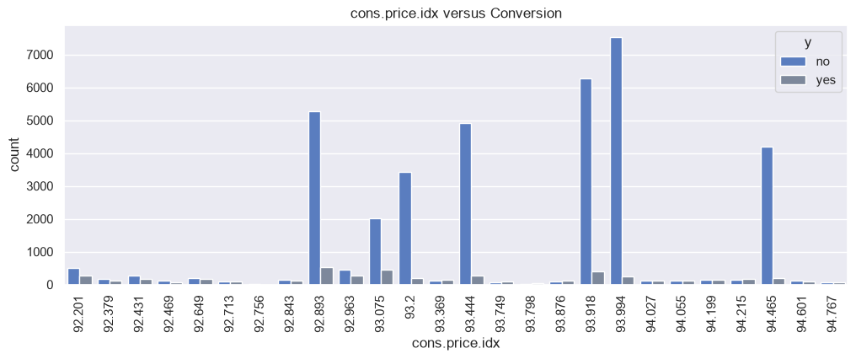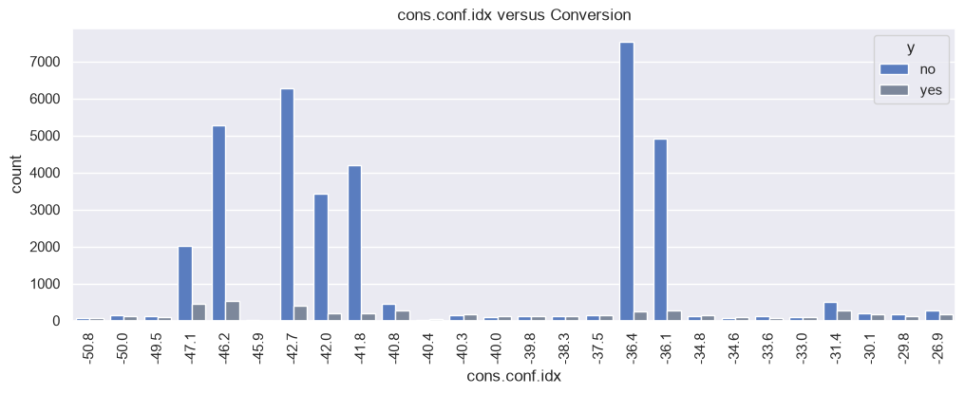
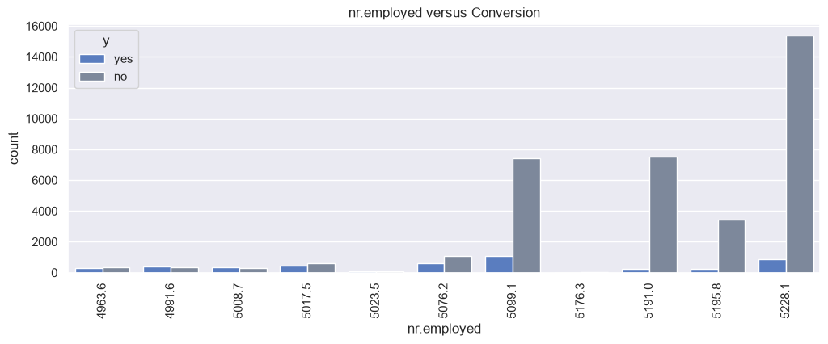

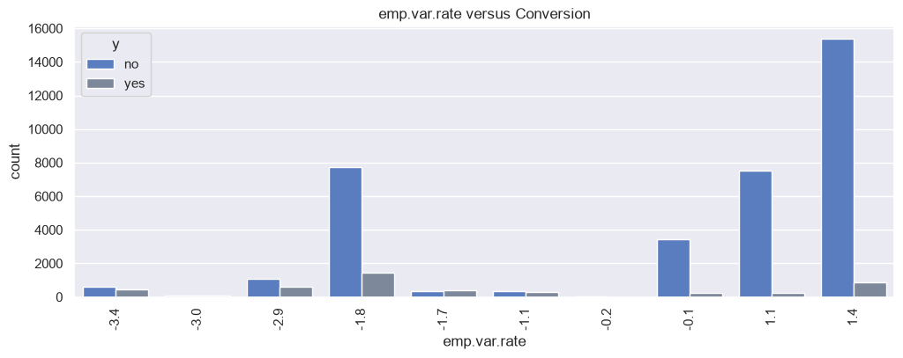

The four macro-economic indicators show a consistent pattern. Most contacts took place when employment variation was highest (emp.var.rate 1.4, 1.1 and -0.1; nr.employed above about 5190), and in those periods the subscription rate was low (roughly 3% to 6%). Subscription rates were much higher when employment variation was negative, where far fewer contacts were made (roughly 15% to 45%, with small groups at the extremes). cons.price.idx and cons.conf.idx follow the same period structure. Because the indicators take only a few distinct values, are highly correlated with each other, and are identical for all clients contacted in the same period, they mainly capture the timing of the campaign rather than client characteristics. Their relationship with conversion should be interpreted as associative, and only one or two of them will be retained after feature selection.

1.5.1 Correlations
Here we will check the correlation matrix using Pearson method to understand the correlation matrix between the 5 economic indicators.
- positive values of emp.var.rate indicate rising employment, which means the nr.employed will also show an increase since it represents the number of people employed.
- cons.price.idx: positive values indicate inflation and lower and negative values indicate deflation. There are no negative values in the dataset, with higher values in the same range. This will have less movement with the above variables
- cons.conf.idx: negative values means pessimistic, zero an even split and positive showing optimism in the economy. Our dataset has only negative values which shows mild to very strong pessimism. Hence, this variable may also not move linearly with the emp.var.rate and nr.employed, and has the weakest correlation with the above
- euribor3m: euribor3m is the 3-month Euribor (Euro Interbank Offered Rate), the average interest rate at which major European banks lend to each other for 3 months. It is the main benchmark for short-term euro interest rates, and it feeds into the rates on many loans and deposits.
- The values are percentages per year. Our describe() output showed a range of 0.63 to 5.04, so a value of 4.86 means 4.86% annual interest.
- Higher means more expensive short-term borrowing, and generally higher interest rates across the economy. Lower means cheap money.
- Negative values are possible for Euribor in general, but none appear in this sample (2008 to 2010).
euribor3m, emp.var.rate and nr.employed are strongly positively correlated because they all reflect the same economic cycle in the sample: high interest rates and high employment in the early period (2008), and falling employment with sharply lower interest rates afterwards. A high euribor3m is not itself an indicator of a healthy economy; it mainly identifies the period in which the contact took place.

Possible reason for correlation in our data set can be due to:
- A term deposit pays more when rates are high, so you might expect higher conversion then. Your bar charts showed the opposite: conversion was lower in the high-rate period.
- The three variables are largely redundant, so we can plan to keep one (often euribor3m or nr.employed) in a model.

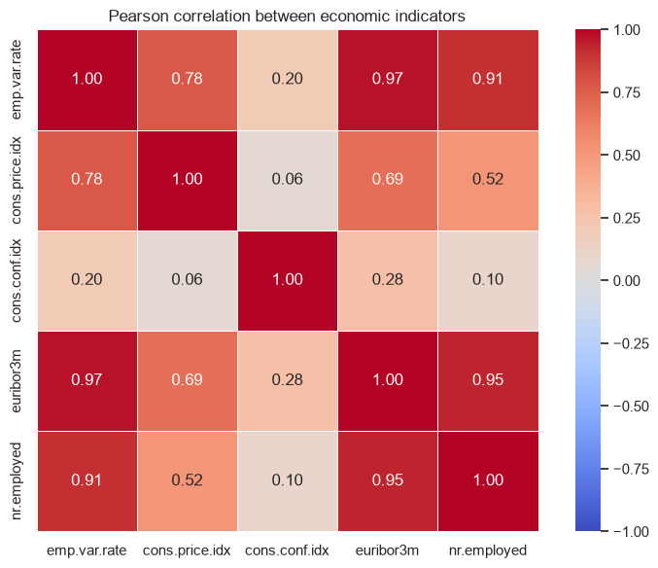
##################################################################################
Data Preparation Stage:
- Remove the duplicates ---- done
- Split data into train and test sets ---- done
- Removing missing data --- no missing data

“unknown values in the categorical variables are encoded rather than imputed, because for default (about 21% of clients) the unknown group converts at a markedly different rate from known groups, so missingness is informative.”
The next step is to hot encode the columns that have. But we will exclude the target variable from this and simply binarize it
- binarize column ‘y’: replace yes and no with 1 and 0 -- done
- Do a one hot encoding for columns ‘job’, ‘marital’, ‘education’, ‘default’, ‘housing’, ‘loan’, ‘poutcome’
- contact, month, day_of_week are text columns that your encoder list leaves alone. Models will fail on them later, so encode them too (for poutcome, with nonexistent as the reference)
- convert months to their relevant numerical values
- convert days_of_week to relevant numerical value. Better drop this column as it is not useful. Verify this with the data understanding part
- Apply exactly the same steps to df_test: the y mapping, ohe.transform(df_test_clean), and the same drop(columns=refs). Never call fit again on the test data.
- Unseen categories become all zeros, which is fine. Also remember default_yes has only about 3 rows, so it will be almost constant; consider dropping it.
- df_train_clean.insert(0, 'y', df_train_clean.pop('y')) works. It is only cosmetic, so remember to separate y before fitting models.
- If you want fewer places to go wrong, wrap the encoding in a scikit-learn ColumnTransformer and Pipeline, which fits on train and transforms test automatically

Things to handle around it
- The other text columns. contact, month and day_of_week are still text. remainder='passthrough' would pass them through unencoded and the models would fail. Add them to cat_cols and refs (for example cellular, may, mon), or drop them deliberately.
- Numeric columns for logistic regression. It also needs scaling (StandardScaler) and the pdays and skew treatment from earlier. Trees don’t.
- default_yes is nearly empty (about 3 rows). It stays as an almost-constant column, which is harmless for trees and for regularised logistic regression. You can also merge yes into unknown before encoding if you prefer.
- housing_unknown and loan_unknown look redundant. They appear to flag the same 990 rows, so check this and drop one if they match.

